Call for Kunioki Mima U30 Scientist and Student Award
2026.02.01AAPPS-DPP BoD

AAPPS-DPP recognizes exceptional U30 scientists/students who have performed original work of outstanding scientific quality and achievement in the area of plasma physics. The selection committee will be formed under the chairmanship of Prof. Kazuo A. Tanaka. Nomination shall be sent to DPP CEO (aapps.dpp.ceo@gmail.com) during March 1-May 31.

[1] Establishment & Support
This award is established and endowed since 2018 by IFE-Forum http://www.ilt.or.jp/forum/index.html under the leadership of late Professor Kunioki Mima and is called after his name since 2025.

[2] Eligibility and Qualification
Nominations by DPP member will be accepted for AAPPS-DPP member U30 young scientist and doctoral student who have published original papers successfully within the current nomination deadline. The age of nominees should be 30 years or less at the first day of the conference is held (Oct. 11, 2026) and current institution or nationality is required to be in the AAPPS region*.
[3] Nomination package: Use attached nomination form for the nomination. No self-nomination is allowed.
Section 1 Nomination and Undertaking by Nominee: Fill in all requested details in Section 1 of the “Nomination Form”. Nominator must be an AAPPS-DPP member. The nominator’s nomination letter (not more than 1,000 words) and seconding letters (at least one and maximum at two, each <3pages) should be attached as appendix.
Section 2 Biographical details of nominee: Fill in all requested details in Section 2 of the “Nomination Form”. No separate CV is needed. The nominee should provide his/her own statement of why he/she deems deserving the award.
Section 3: Scientific contributions of the Nominee: Fill in all requested details in Section 3 of the “Nomination Form”. Attach copies of nominee’s main paper as appendix. Please provide links to Web of Science (WoS) and Google Scholar citation records.
Section 4: Full list of publication (including books): List should include WoS citation number for each paper (for possible papers recorded in WoS) and Google Scholar citations (including Books). Use Web of Science (https://access.clarivate.com/login?app=wos). Include information on the journal impact factor for a main paper.
Attachments: 1) Nominator’s nomination letter. 2) Seconding letter(s). 3) Copy of main paper.
[4] Award ceremony and talk: The selection of winners will subject to the peer review of the research achievements. When it is necessary, the balance of distribution of winners’ fields, gender and region may be considered. Winner should give an oral talk (or plenary or invited if selected) on the awarded work at the AAPPS-DPP 2026. Committee will select about five winners. Winner will receive a certificate and US$300.

*: AAPPS region shown in Green.
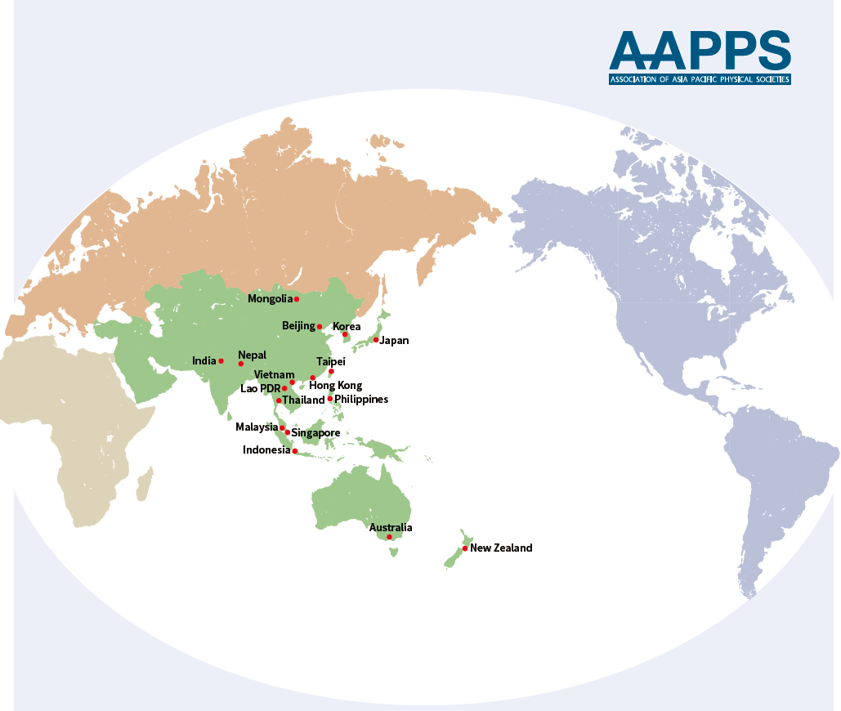

2026 Nomination form for the Kunioki Mima U30 Scientist and Student Award

Note: Please carefully prepare all parts of the nomination form, including Section 1- 4. After completing and signing the form, please make the pdf of the file and submit the pdf files only. Please arrange Section 2-4 starting from new pages.

Section 1: Nomination and Undertaking by Nominee

The Nominee
Name
Affiliation
Membership ID number
No self-nomination
The Nominator*
Name
Affiliation
Membership ID number
Nomination letter should be limited to maximum of three pages.
Seconding persons*
Name #1
Affiliation
Name #2
Affiliation
*Not limited to AAPPS-DPP members but must be from well-known experts in the field. Each seconding letter should be limited to maximum of three pages, signed and on the letterhead of the expert seconding the nomination.
Proposed citation for the Award (less than 50 words):

Signature of Nominator: Date:

Undertaking by Nominee
I, , hereby agree that if selected for the Kunioki Mima U30 Scientist and Student Award, I will participate and present a talk at the AAPPS-DPP2026 annual conference.

Date: Signature of Nominee

For Office use
Date of Receipt:
Whether considered earlier: Yes/No
If Yes, years of consideration:

Section 2: Biographical Details of Nominee

# | Item |  | Description
1 | Full name:
2 | Title/current position:
3 | Affiliation:
4 | e-mail ID:
5 | Date and place of birth:
6 | Age at 1st day of conference:
7 | Nationality: |  | Present: |  | Past (if any):
8 | Education :  PhD  Master  Bachelor |  | Year | Degree | University/Institution
9 | Career History (in reverse chronological order) |  | e.g.*  1. Associate Professor, University of XYZ, PQR (2008 – 2002)  2. Assistant Professor, University of XYZ, PQR (2002 – 1996)
10 | Journal Services:  (Editorships and Editorial Board Memberships) |  | e.g.*  1. Associate Editor of RMPP  2. Associate Editor of XYZ  3. Editorial Board Member of XYZ
11 | Visiting Positions: |  | e.g.*  1. Guest Professor, Kyoto University (1999-2002)  2. Visiting Professor, Chinese Academy of Science (2010-2012)
12 | Society Services: |  | e.g.*  1. Council member of XYZ, (2020-present)  2. XYZ committee member, US National Academy of Science (2014-2016)
13 | Memberships: |  | e.g.*  1. Member, Chinese Physical Society  2. Member, Division of Plasma Physics, AAPPS
14 |  | List of past scientific awards/recognitions of nominee  e.g.*  1. Elected member, TWAS (year)  2. XXX Medal, Australian Institute of Physics (year)
15 | Personal or Institutional web page (if any)
16 |  | Nominee’s statement of why he/she deems deserving the award. (<200 words).
*Please replace light grey text by relevant information.

Section 3: Scientific Contributions of the Nominee

1 |  | Critical summary of the most seminal/original contributions of the nominee in plasma physics by the nominator (<200 words).
2 |  | Main paper and description of its seminal/original contribution to plasma physics (each<300 words).  [In case of multi-authored publications the specific contribution of the nominee should be clearly given.]
 |  | [1] Kazunori Takahashi,Trevor Lafleur,Christine Charles,Peter Alexander,and Rod W. Boswell1, Electron Diamagnetic Effect on Axial Force in an Expanding Plasma: Experiments and Theory, Phys. Rev. Lett 107(2011)235001
4 | Nominee’ Publication  (total numbers only, details later) |  | Number of Refereed Journal Papers
4 |  |  | Number of Books
5 |  | Nominee’s Citation Summary (Inc. books) |  | WoS Citation Count: | WoS H-index:
 |  |  |  | Google Scholar Citations: | Google Scholar H-index:
6 | Link to Nominee’s |  | Copy links below:* [example is 2018 laureate and replace to nominee’s link]
6 | Google Scholar  Web of Science |  | https://scholar.google.com/citations?user=61ld9voAAAAJ&hl=en  https://www.webofscience.com/wos/author/record/1655688
*Please replace light grey text by relevant information.

Section 4: Full list of publications (including books)
- Format of entry: In order of higher citation number in Google scholar. Each paper in order of Authors, Paper/Book/Book Chapters title, Journal/Publisher name, volume, pages, and year. Refer sample.
- For each entry, all co-authors should be listed. We will use it to check COI with Selection Committee members.
- Nominee’s name should be in bold. Put # mark if the nominee is the corresponding author or the co-first author.
- For important 2 papers, Highlight the cell with light yellow colour for five best papers. Please mention the impact factor (IF) and the DOI for these important papers.
# | Paper (authors, paper title, journal volume, year, page)  / Book (authors, book title, publisher, year) with candidate name in bold | WoS cites | Google cites
1 | A B First, C D Second, E Third#, and F G Fourth, Physical Review Letters xx, zz (YYY). IF – 7.6, DOI: https/… | 50 | 70
2 | A B First, E Third, C D Second and F G Fourth, Journal of Astro Plasma 37, 3337 (2021). | 30 | 45
3
4
5
6
7
8
9
10
11
12
13
14
15
16
17
18
19
20
21
22
23
24
25
26
27
28
29
30
31
32
33
34
35
36
37
38
39
40
41
42
43
44
45
46
47
48
49
50
51
52
53
54
55
56
57
58
59
60
61
Extend or delete the number of rows, as needed, to present the full list of publications. Replace the grey sample text with actual information of the nominee.
Attachments:

- Nominator’s nomination letter of less than 3 pages.
- Seconding letters from two leading experts in the field of less than 3 pages each. The experts need not be AAPPS-DPP members.
- Copy of the main paper of the nominee as listed above.
- For age verification, relevant page of copy of passport may be requested.
The completed form with the above attachments should be submitted by email to the DPP CEO at (aapps.dpp.ceo@gmail.com) in one pdf file before the deadline stipulated in the announcement.

