Abstract for IAEA-TM (title with 14 pt, Bold)

MIMA Kunioki, and FAMILYNAME Given Name¹⁾, (12pt)
Institute of Laser Engineering, Osaka University, Suita, Osaka, Japan (12pt italic)
1) LLNL Livermore, CA, U.S.A.

1. Introduction
The Fourth IAEA-Technical Meeting on Physics and Technology of IFE Targets and Chambers will be held at the International Conference Center Kobe, Kobe Japan, September 13 2007 in a style embedded in IFSA 07. [1]

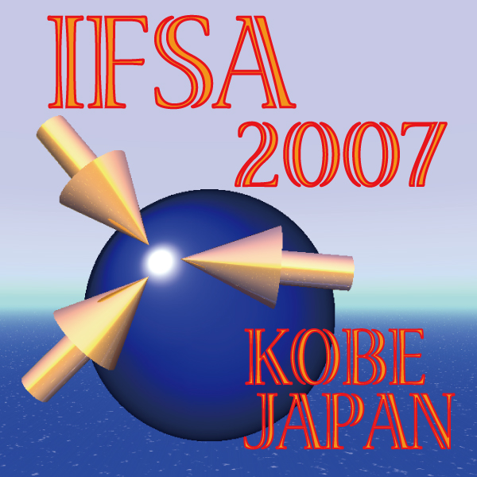
Figure 1: The log of IFSA 2007.

2. Abstract
Abstract should be written in clear English on an A4 size paper (297×210 mm) with a 25 mm margin on all sides. The text should be typed in one column format with 12 pt font size. “Times New Roman” font or equivalent is recommended. The total length will be limited to one page for all presentations. Page number should not be added for easily making the abstract book. Please refer to the sample MS-WORD file for more details.
Prepare a PDF file of your extended abstract which should involve all fonts and graphics used in the file. The authors are requested to check the computer file by themselves. The conference secretary does not take care of repairing files in incorrect or insufficient format.
We would appreciate it if the authors make the PDF file size less than 500 Kbytes for saving the storage of our Web sever. Thank you for your cooperation.

References
[1] Web page of IFSA’07 (http://www.ile.osaka-u.ac.jp/ifsa07).
[2] K. Mima and K. Tanaka, First Announcement of IFSA07. 1 123-456 (2006).

